BookFlow Lab Guide
Experiment 2: FastAPI Backend & Security Suite
Project setup
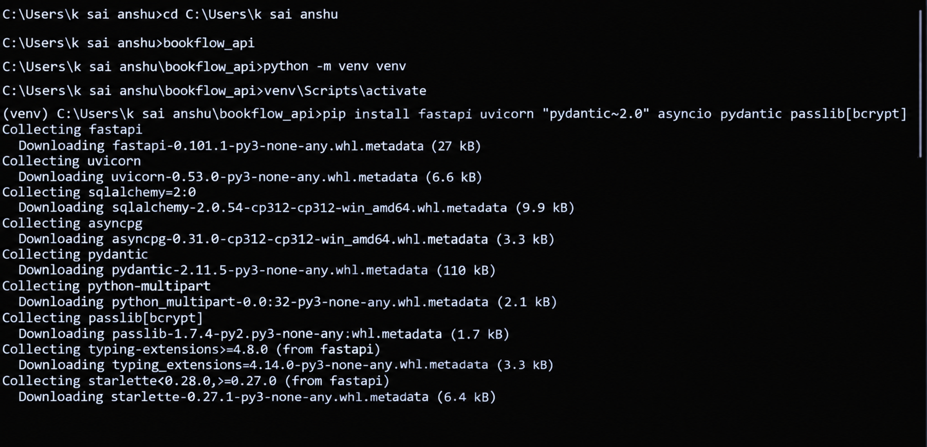

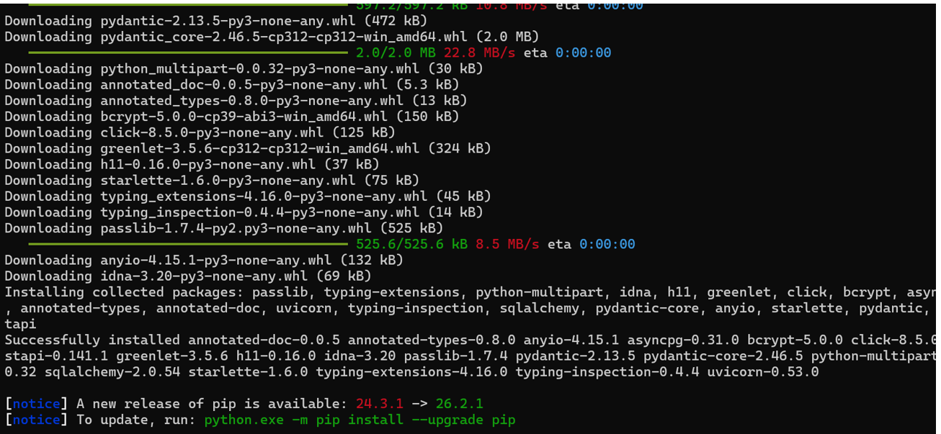

database.py (async connection)
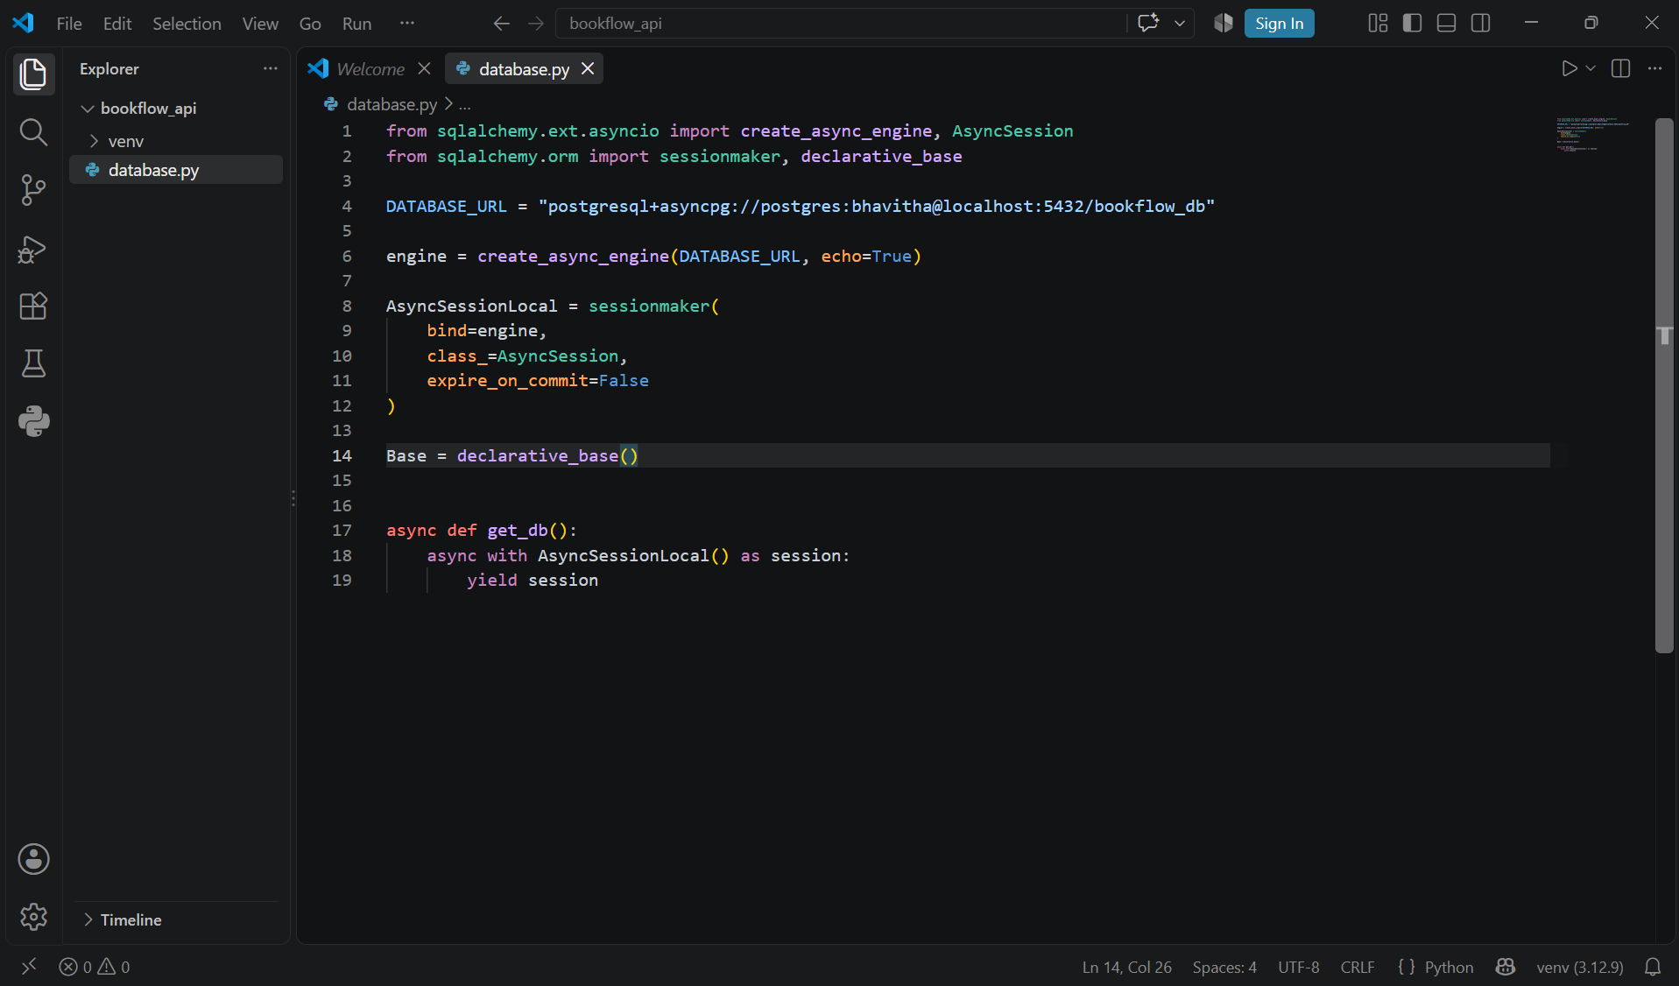
models.py (SQLAlchemy ORM model)
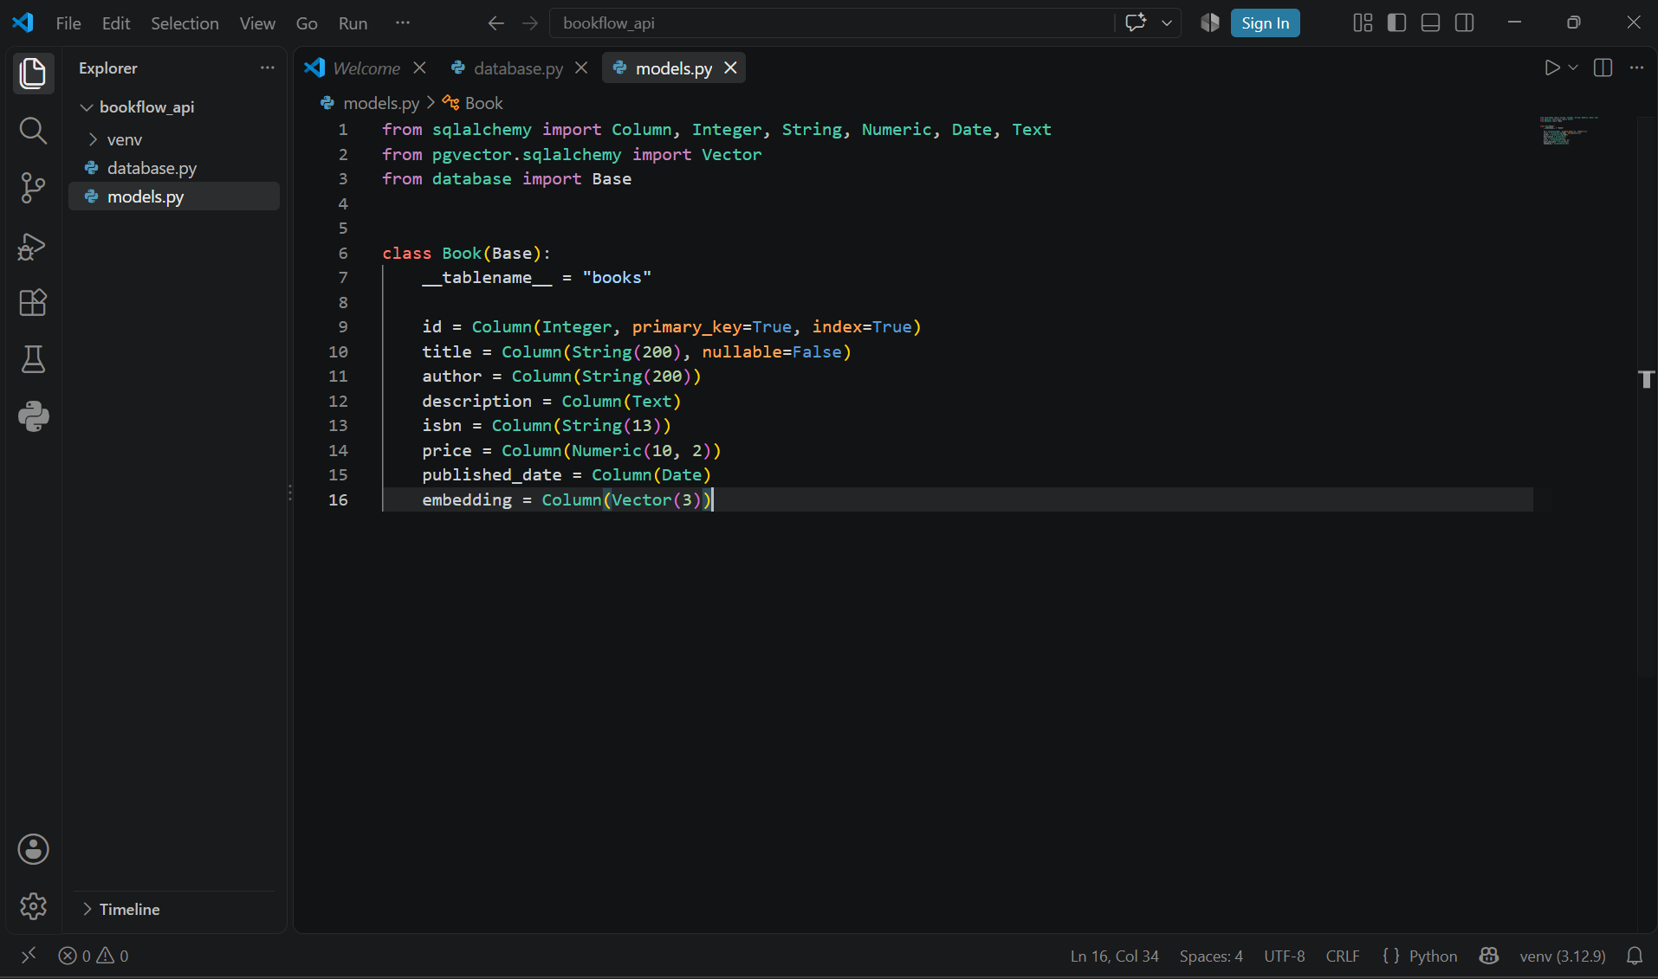
schemas.py (Pydantic validation)
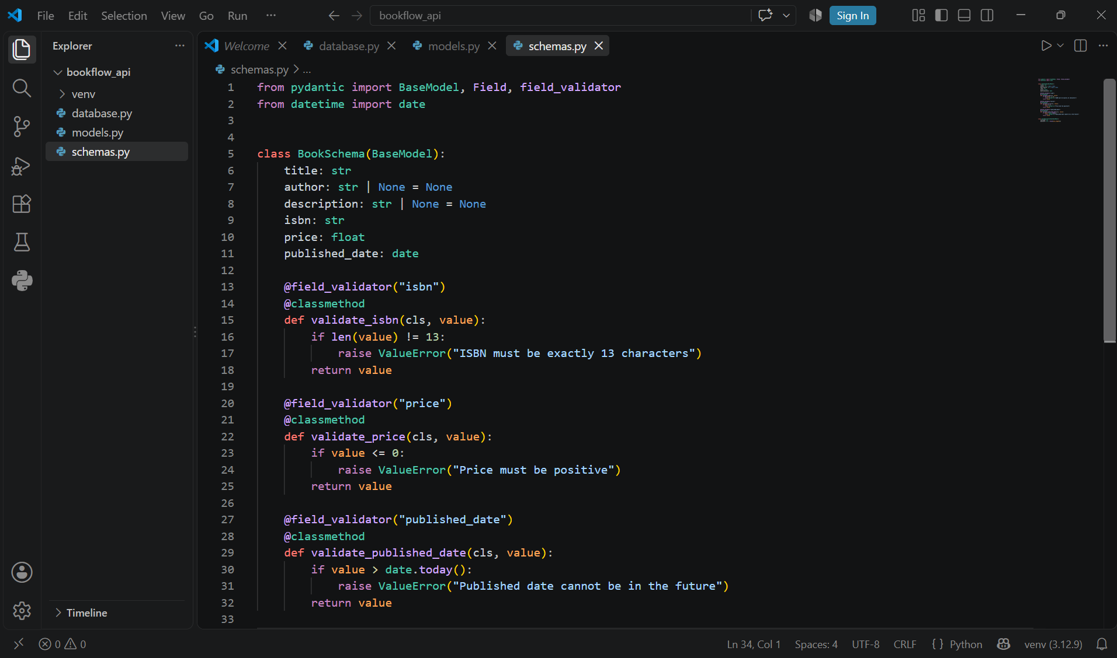
main.py (FastAPI app, routes, auth)
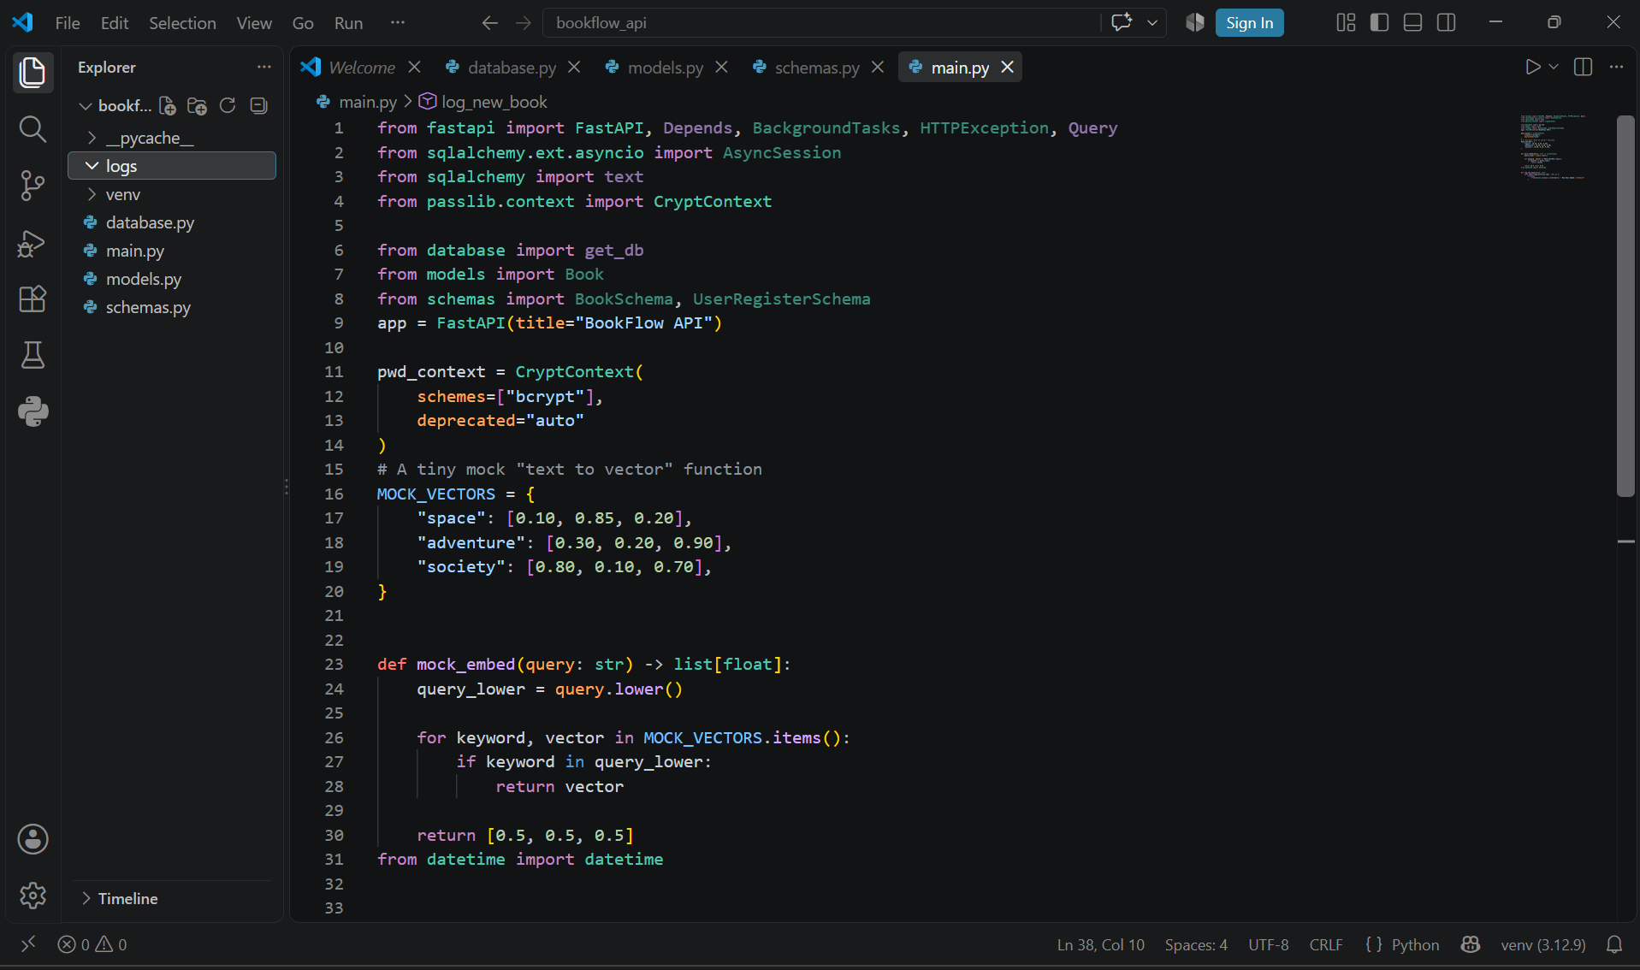
Run the server
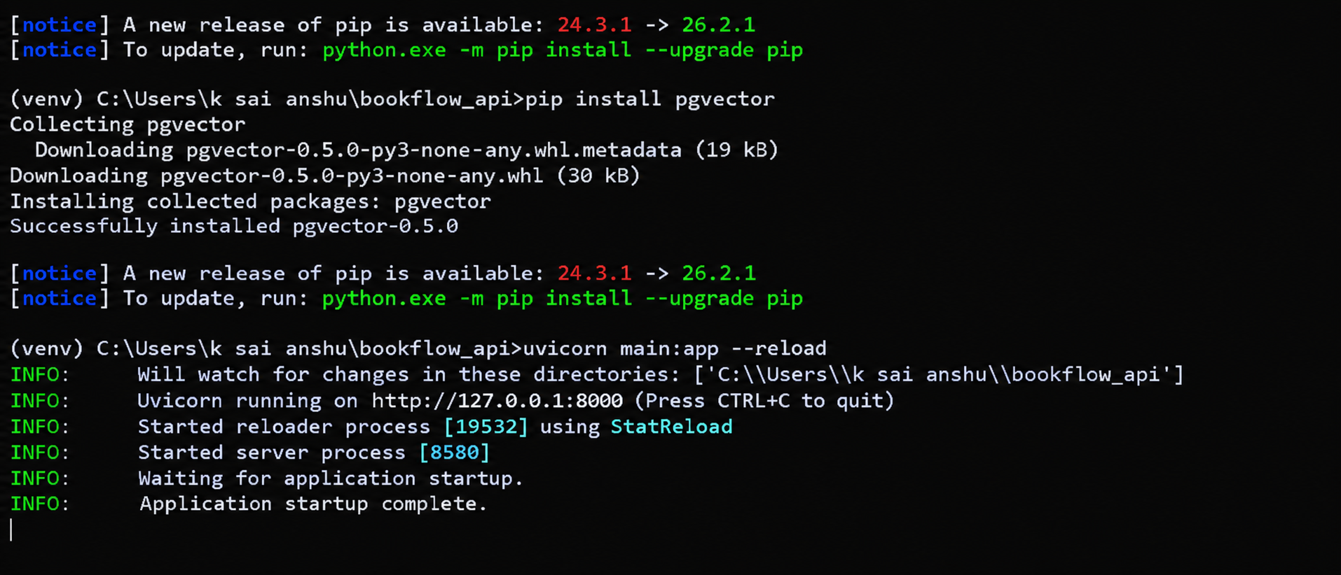
Test it in the browser (Swagger UI)
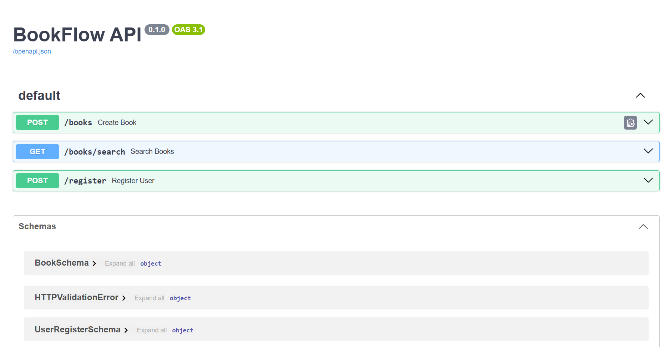
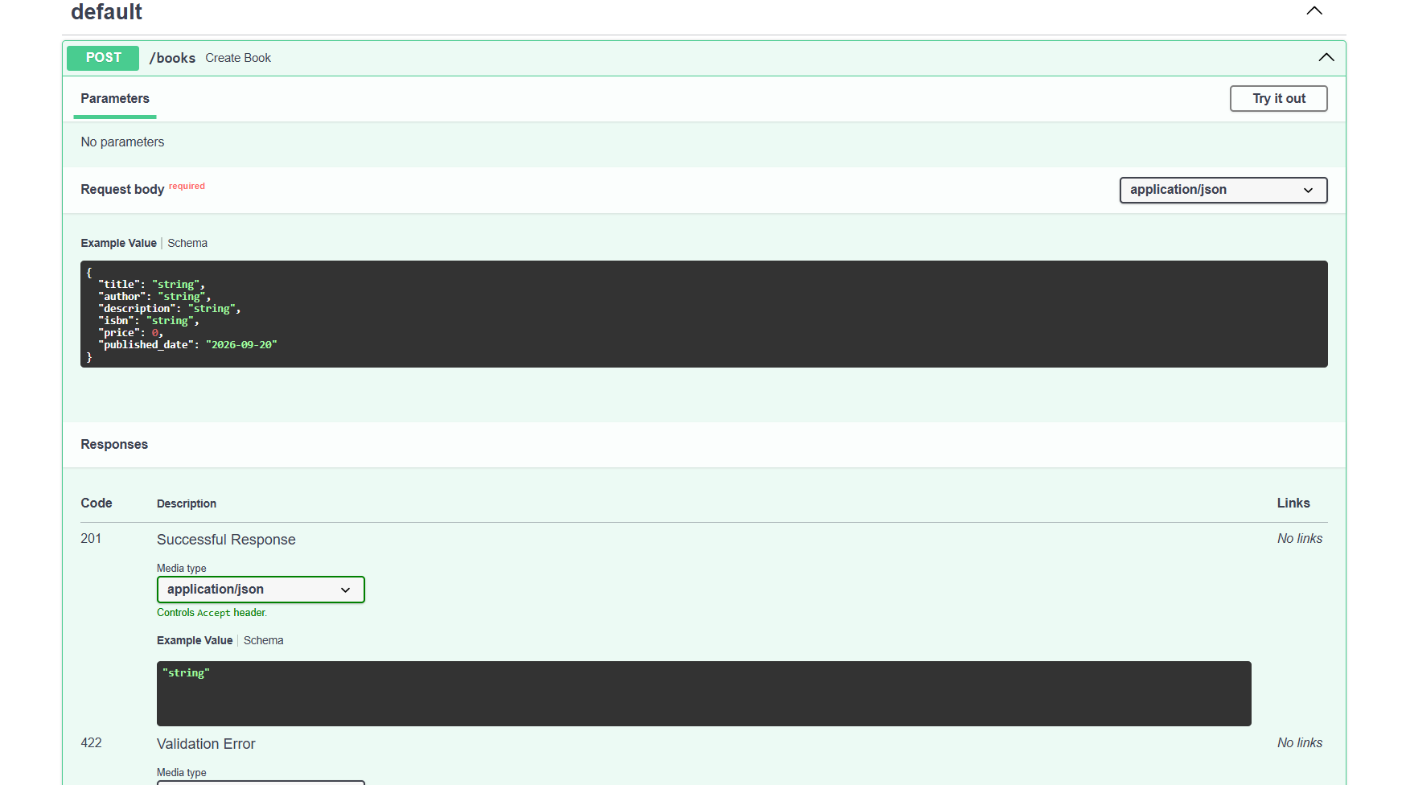
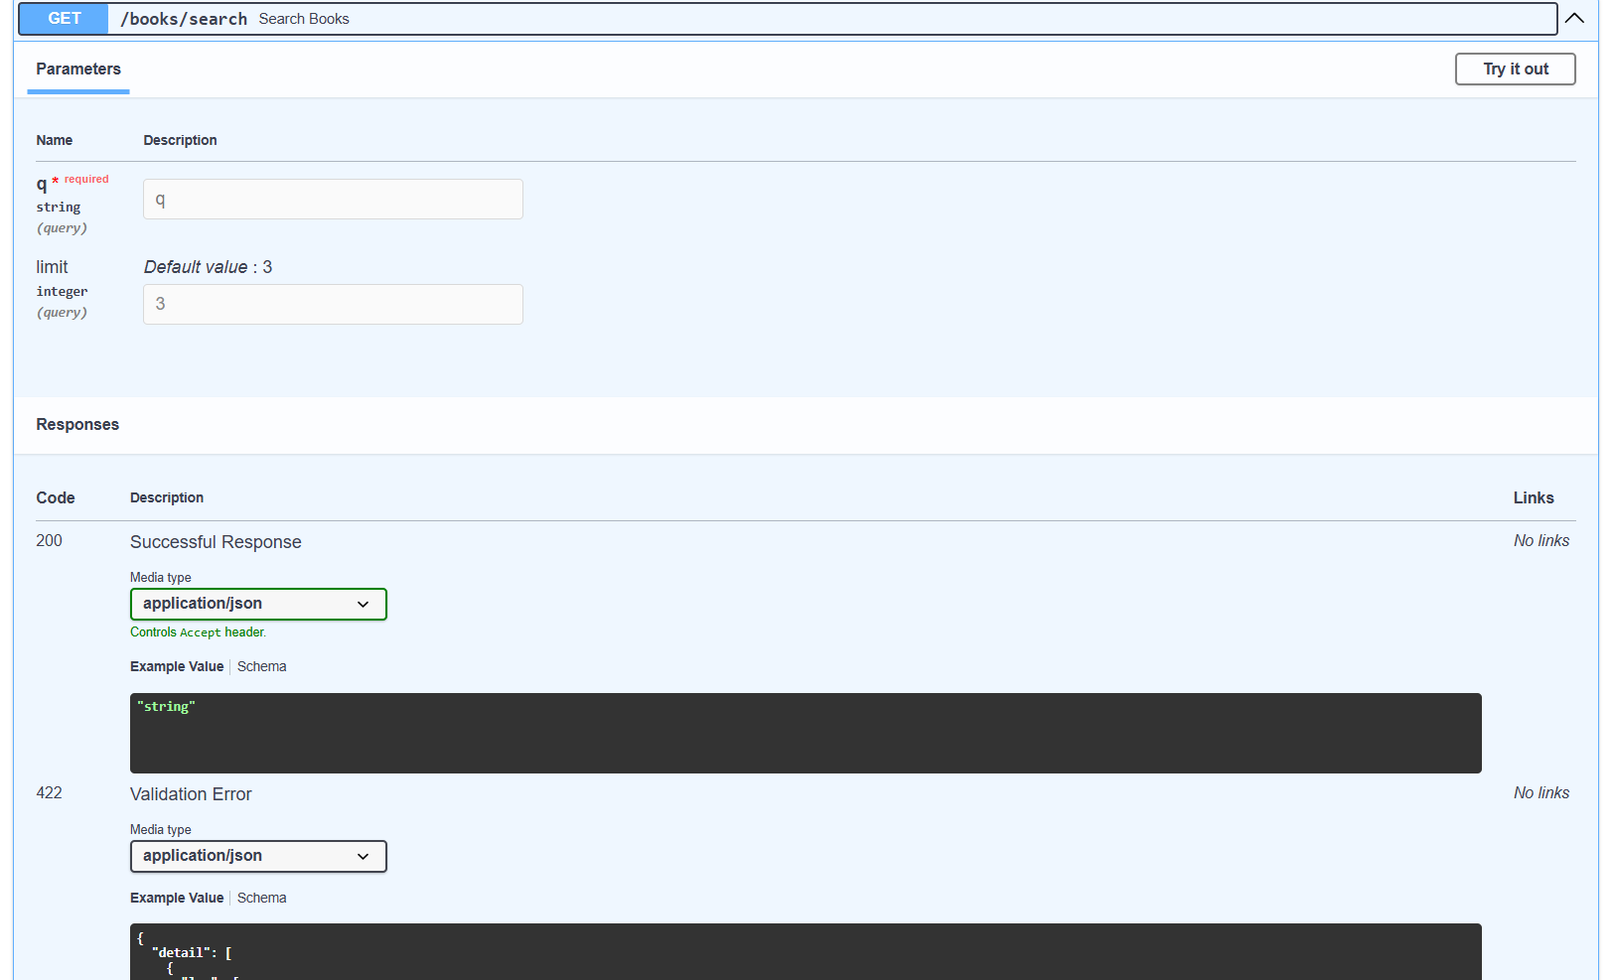
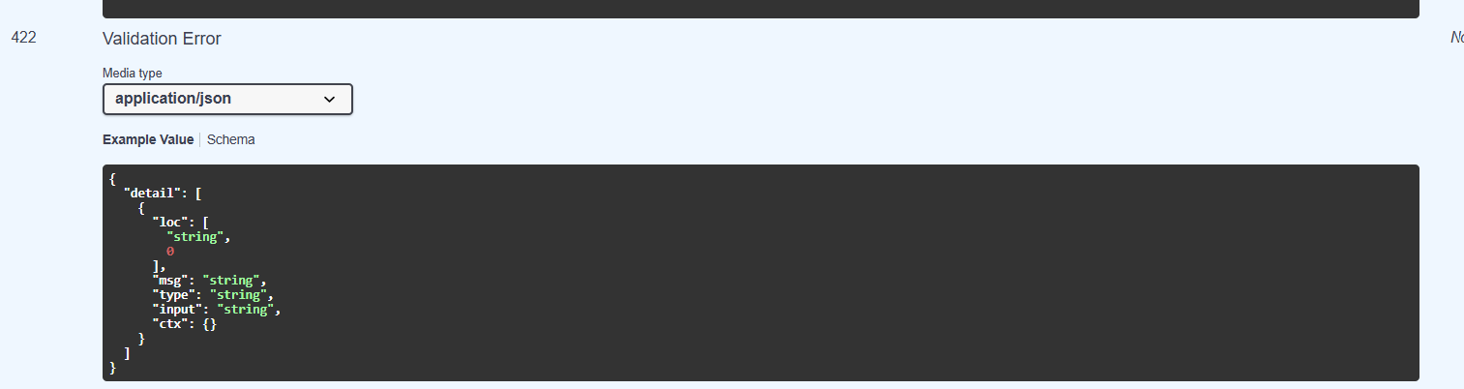
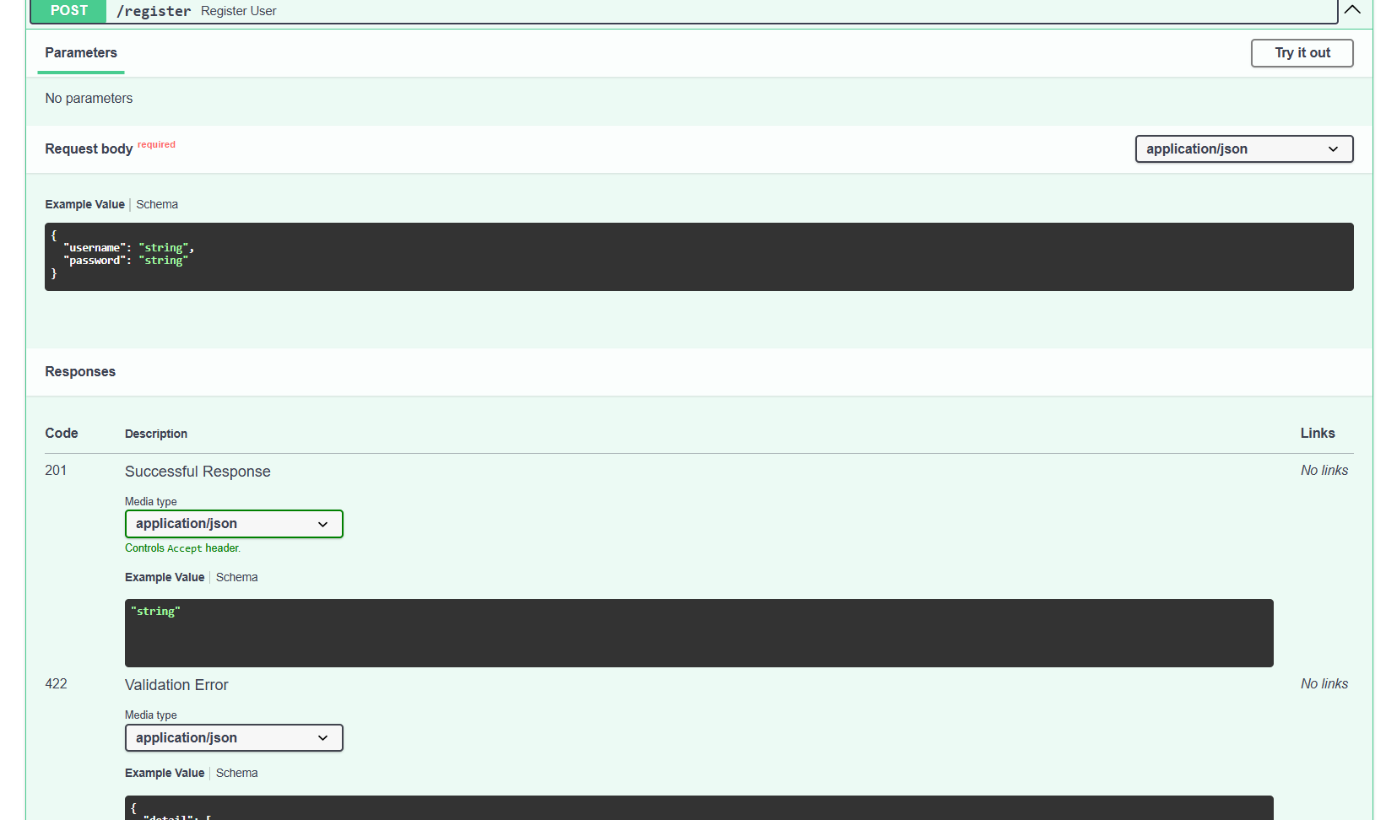
Test invalid q
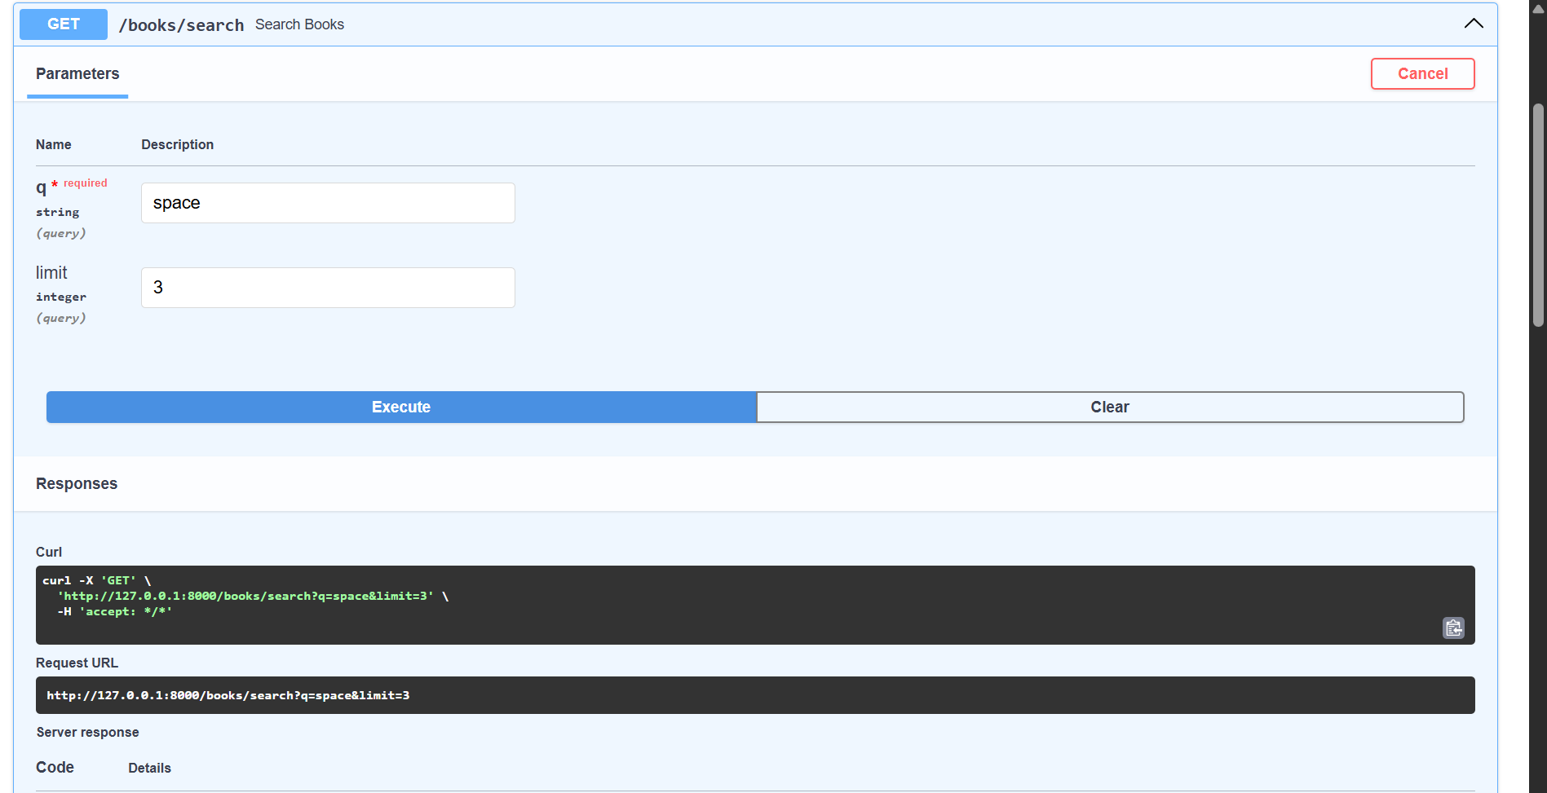
Test invalid limit
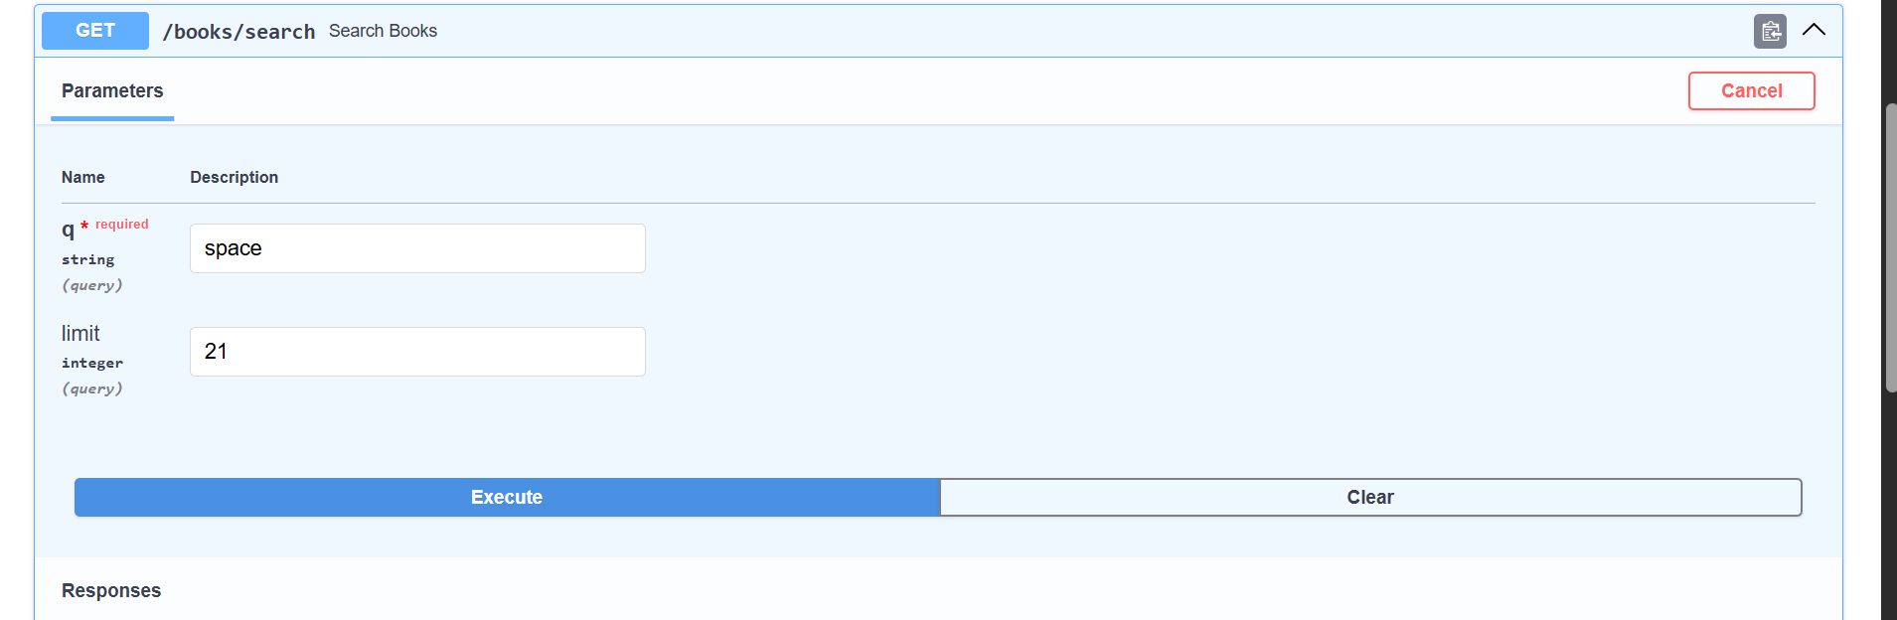
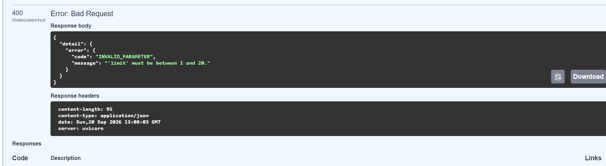
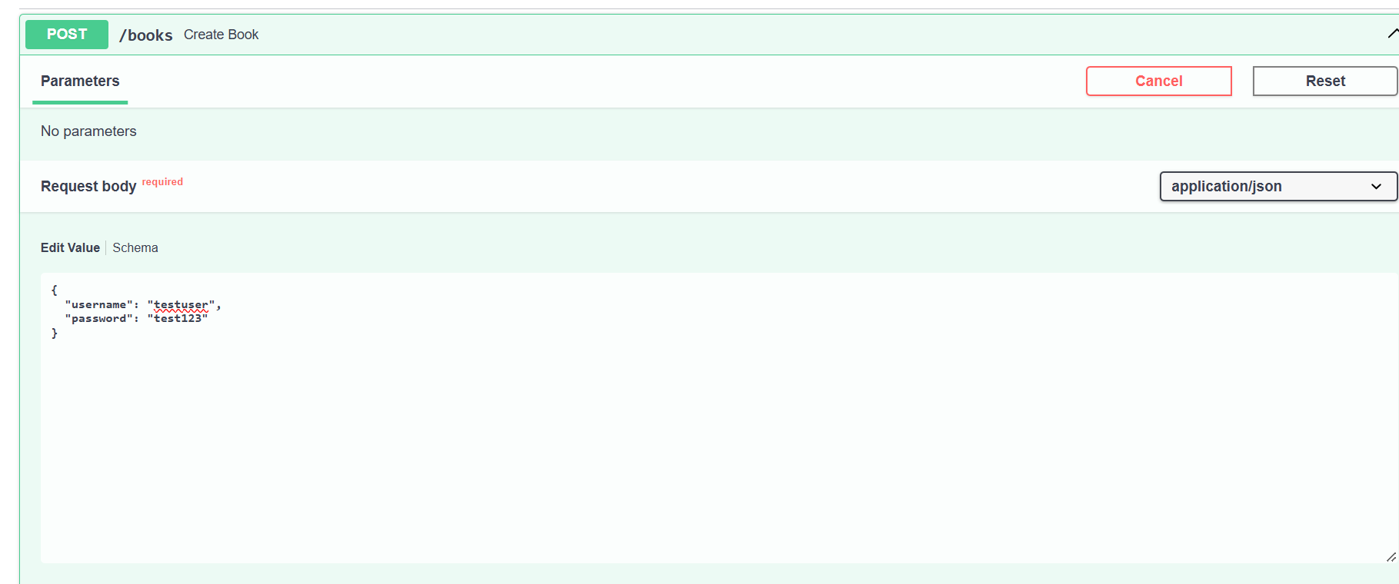

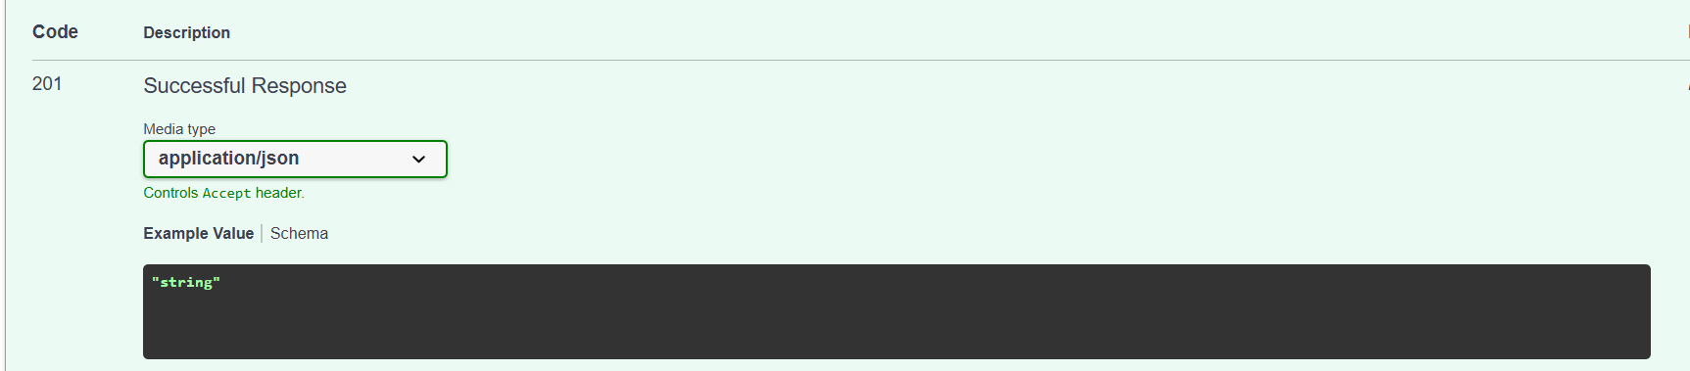
Conclusion:
The BookFlow FastAPI backend was successfully implemented and tested. The experiment demonstrated REST API development, request validation, PostgreSQL database integration, semantic book search using pgvector, password hashing using bcrypt, and background task logging. The API endpoints were tested successfully through Swagger UI, including successful requests and validation error cases

